Citation: Siraj-Blatchford, J. & Brock, L. (2016) Putting the Schema back into schema theory and practice (Part 2), Early Years Educator Magazine, February, download at: http://www.magonlinelibrary.com/doi/10.12968/eyed.2016.17.11.18

Series title: Putting the Schema back into Schema Theory and Practice
Prof John Siraj-Blatchford and Lynnette Brock
Part One: Putting the Schema back into Schema Theory and Practice

Current texts on the topic of ‘scheme’ and ‘schema’ often refer to Piaget’s (1962) cognitive development theory and his early publications concerning how children learn, to which he applied the term schema to children’s general cognitive structures:

“Schemas of action [are] co-ordinated systems of movements and perceptions, which constitute any elementary behaviour capable of being repeated and applied to new situations” (Piaget, 1962: 274).

Piaget recognised that the behaviours children display in their play are like building blocks of conceptual development, which are constantly changing or being modified to the child’s developing experiences. He believed that as a child encounters each new experience, s/he will review prior knowledge to make sense of what an object ‘does’ and what an object ‘is’ (Piaget, 1962). The schema is therefore constantly being revised and elaborated upon each time the child encounters new experiences.

The essence of Piaget's concept of sensory motor intelligence is that infants construct their knowledge of the world from motor activity. As Fagard and Wolff have put it "Mental representations (ideas, plans, images, thoughts) are internalised motor activity" (p179). While Piaget developed his model primarily from the perspective of the child’s earliest development, all of this may be considered consistent with Vygotsky’s notion of the tools of intellectual adaptation that are gained from the surrounding culture. For Vygotsky, child development was considered to involve a progressive internalisation of, and adaptation to, the culture that is achieved later primarily through language (Rogoff, 1990). The implications of this for education are, as Bodrova and Leong (2007) have noted:
"... the tools are learned from adults and suggest that the role of the teacher is to ‘arm children’ with these tools. This sounds simple, but the process involves more than merely direct teaching of facts and skills. It involves enabling the child to use the tools independently and creatively. As children grow and develop, they become active tool users and tool makers; they become crafters. Eventually, they will be able to use mental tools appropriately and invent new tools when necessary"( Bodrova and Leong, 2007: p4.)
Following Neisser (1976) and Anderson (1977), we may identify the following as the main characteristics of mental ‘schema’ as they have come to be generally understood:
- they are organised in the mind in a meaningful way;
- they are embedded within superordinate and subordinate schemata;
- different schema may be applied in the course of an interaction with the environment;
- schema are reorganised when they commonly or calamitously fail to be useful;
- they are more than the sum of their parts, and they tend to reify and bias our perceptions (they are emergent and gestalt mental representations).

The concept of schema was introduced in the first instalment of this series of articles last month. In the final instalment, next month we will explain how emergent literacy and other sophisticated emergent cognitive operations are developed through schemas. The pioneering work of Chris Athey (1990) was also identified in the previous article. In her Froebel Research Report and subsequent publications, Athey identified a number of very commonly repeated and intrinsically motivated patterns of children’s behaviour in play, which she named according to their characteristics such as ‘enveloping’, ‘rotating’, ‘going under and over’ etc. Athey referred to these behaviours as schema and argued that their use by children should be encouraged. 'Schema theory and practice', as has come to be commonly applied in early childhood education, therefore involves the practitioner in at first identifying and then encouraging these 'patterns of repeated behaviour', into which new experiences are then 'assimilated and gradually co-ordinated' (Athey 1990, p37). Athey (1990) hoped that providing educators with knowledge of schemas might help them to meet the needs and support children’s learning more appropriately. As Nutbrown (2006) has explained:
“If a child is say focussing on schema related to roundness, we could say that the child is working on a circular schema. The form is ‘roundness’ and the content can be anything which extends this form: wheels, rotating machinery, rolling a ball…” (Nutbrown, 2006: p11).
As Nutbrown (2006: 14) has argued there is good supportive evidence of the benefits this work as a knowledge of schemas is helpful to practitioners in terms of their:

“observations, planning, teaching, assessment, record-keeping and reflection … [and enable educators to] … create situations which challenge young children, enable ‘fine tuning’ of thinking and action, and ensure equality of access and curriculum.”

Grenier (2009) and others have at times been more sceptical and questioned whether it is in fact necessary to be aware of the behaviours that Athey (1990) identified. Schema theory and practice might simply be considered:

“…what good early years’ educators have always done – starting with the child’s actions and interests, and encouraging more complex movement, play and thought?” (Grenier, 2009: unpaginated).

In Piagetian terms, the implication is that as the adult is encouraging the child to apply the schema in different contexts and encouraging its deeper cognitive assimilation. But the popular literature on schema theory and practice also makes occasional reference to learning that may go beyond assimilation and might be interpreted as encouraging the accommodation of novel schema as well. As Athey put it, “schemas become co-ordinated with each other and develop into systems of thought” (Athey [1990] 2007). Meade and Cubey (2008) take the example of the ‘back and forth’ schema;
“…seen in a toddler who brings items and dumps them in the lap of a familiar adult. These may become coordinated (or ‘connected’) later with ‘going and coming’ between home and the early childhood centre. Added together, these two periods of exploring ‘transporting’ schema may form the foundation of map-reading that is developed in middle childhood”. (p50)
As Nutbrown (2006) has suggested schemas connect, evolve, supporting complex concepts; she provides the example of Athey’s description of how early: “…’back and forth’ schemas can later become ‘back and forth’ actions, supported and extended with stories of ‘going and coming’, map reading and map making” (1990 in Nutbrown, 2006: 11).

Arnold (2012) also cites Gopnik (1999) when carrying out her research and observations of her granddaughter ‘Gabriella’. Gopnik et al (1999) suggest, from birth onwards, young children are playfully exploring the world and it is these explorations that enable them to make ‘generalisations’ based upon their experiences. Arnold noted that Gabriella carried out an extended series of similar actions, and that these actions were supporting her to make ‘generalisations’ of how she could apply them to different objects.

As noted in our discussion of free-flow play in last month’s edition of EYE, it is notable that in his later work, Piaget (1969) applied the term schema only to figurative knowledge; a change to his earlier more general application. Piaget (1962) came to believe that learning involved a progressive cyclical process in the development of figurative (or symbolic) ‘schema’, and their operative ‘schemes’. As a child encountered each new experience, s/he referred at first to their prior knowledge to make sense of what an object ‘did’ and then what an object ‘was’. Piaget therefore posited a new term, ‘scheme’, which he explained as the operational processes that are acquired and applied, and then re-applied in the development of new schema:

“The terms ‘scheme’ and ‘schema’ correspond to quite distinct realities, the one operative [a scheme of action in the sense of an instrument of generalization] and the other figurative” (Piaget, 1969: ix).

The term that we apply in describing the patterns of behaviour that children use in their play might therefore be more properly considered Schemes rather than Schema. Athey’s was aware of this distinction and acknowledged that:
“If more were known about the build-up of coordinated schemas [schemes] and concepts [schemas] more would be known about how best to teach some of the key concepts of the curriculum right through schooling” (Athey, 2007: 114).
As we argued in the previous article, schemes and schema’s should both be recognised as being constantly revised and elaborated upon as the child encounters new experiences. In his thoughtful consideration of schema theory, Grenier (2009) also helpfully draws attention to the findings of the Cambridge Primary Review of research evidence (Alexander et al, 2010):
"Piaget's recognition that children actively construct their knowledge of the world through their action upon it has been upheld. As Gosawmi and Bryant explain, the discovery of 'mirror neurons' (brain cells which fire both when a person performs an action and when they observe someone else performing it) indicates that sensorimotor knowledge is the starting point of cognitive development, but that it is augmented rather than replaced by symbolic representations 'gained through action, language, pretend play and teaching'” (p91).

To illustrate the potential strength of our identification of Schemes and Schemas in practice we can take the example of Alexa, a 4 year old child that we have observed in her Montessori preschool classroom in North London. Alexa had been observed showing all the characteristics of enclosing/enveloping scheme, as identified by Athey, in an extended series of activities. One week later, in the last observation recorded in that session, it was noted that Alexa appeared to be utilising her scheme of covering areas/objects in a different way:

Alexa is working with an adult on a focused activity. She is invited to place a letter in front of two other letters (‘a’ and ‘t’). The sounds of a/t combined are introduced to Alexa and she is encouraged to select another letter and place it in front of the other two. With support she blends the letters together. Alexa then starts to fold the table mat which the letters have been placed on in half, then in half again. She then unfolds the mat and says, “The letters are here.” She selects new letters and blends ‘p/a/t’. When this is done she folds the table mat in half and then in half again over the letters. She then unfolds the mat again and then rolls it up enclosing the letters.(B27,09,15/10.40)

Two weeks later Alexa has selected an activity - a small tray and container housing plastic cubes, which can be fitted/stacked together to build a tower or word build. Alexa has emptied the entire contents and is carefully positioning each cube inside the container. She places four cubes immediately down the left hand side and alongside these she positions a further four cubes. Alexa announces, “This is eight”. She then decides to work out how many cubes she needs to fit down the length of the tray and later across the width of the tray. (B/12.10.15/10.15)

These observations suggest that Alexa is using the enveloping scheme in a more sophisticated way, which may be providing important developmental prerequisites for her to later understand the mathematical schema of ‘area’, length’ and ‘width’ and their formal measurement. By noting and appreciating the differences between scheme and schema, the teacher was much better equipped to support Alexa’s developing mathematical knowledge of space, area and measurement.

On another occasion, Alexa was observed talking to a friend: “I will make lots of small pizzas too”.

Alexa rolls up some playdough into a large ball to make smaller balls. She advises her friend: “All these will be little pizzas!”

Alexa makes eight small ‘pizzas’, turns a bowl upside down and puts the ‘pizzas’ inside. She says: “Now they are cooking”,

After a short time she lifts up the bowl and says to her friend: !I can smell them – they are ready”. (B/20.10.15/11.05)

The discrimination in terms of size that was illustrated by the ‘pizza’ dialogue, and by Alexa’s actions provided an indication that Alexa might benefit from further activities which focused on the schemas; ‘big’ and ‘small’. In this Montessori context the teacher presented resources that encourged seriation by height and she was shown how she could discriminate visually between them. Alexa then had the freedom to access the materials again during the three-hour ‘free flow play’ ‘work-cycle’ prescribed by Montessori to provide children with uninterrupted engagement in their own choice of activities. Alexa therefore had the opportunity to apply her newly acquired schemes and schema in new contexts and personally meaningful ways.

Our account of the learning in free-flow play applied a popular model of cognitive development that assumes the development of figurative representations (Schema), and operative representations (Schemes) in the mind. Following Piaget, Furth and many other developmental psychologists as noted above and in our previous article, we have found it useful to present these as two distinct features of every item of knowledge. It may be useful to consider the Schema and the Scheme, analogous to the two sides of a coin, which may be considered for many other purposes entirely holistically. But as children get older and their learning becomes more dependent on cultural transmission and language then we might more usefully apply the alternative logic of embedded or distributed cognition, where Gibson's ecological theory of development may be applied more consistently with each scheme understood as the affordance of a schema.

Play within the Zone of Proximal Flow
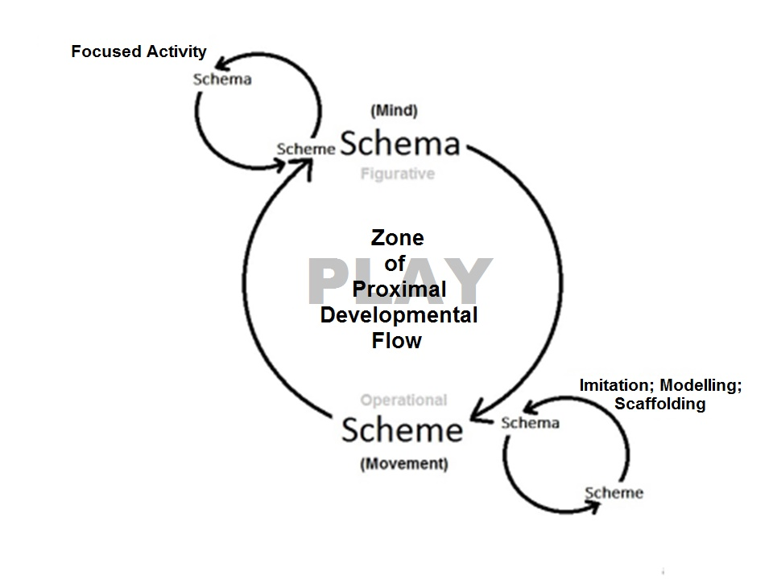
John Siraj-Blatchford in an honorary Professor of Early Childhood Education at the University of Plymouth and Lynnette Brock is a lecturer and researcher at the Montessori Centre International College in London. Further information may be found at: www.schemaplay.com

References

Arnold, C. (2015) Schemas: A way into a child’s world, Early Child Development and Care, 2015 Vol. 185, No. 5, 727–741, http://dx.doi.org/10.1080/03004430.2014.952634
Athey, C, (1990) Extending Thought in Young Children, London: Sage Publications
Bruce, T. (2004) ‘Play Matters’ in Abbot, L. and Langston, A. (eds) Birth to Three Matters: supporting the framework of effective practice, Open University Press: Maidenhead
Fischer, K. W. (1980). A theory of cognitive development: The control and construction of hierarchies of skills. Psychological Review, 87, 477-531.
Gibson, E.J. (1969) Principles of perceptual learning and development, New York: Meredith Corporation
Gopnik, A., Meltzoff, A., & Kuhl, P. (1999) How babies think, London: Weidenfeld and Nicolson.
Grenier, J. (2009) Schema theory in early years education, Blogspot, 23.11.09, Available at: http://juliangrenier.blogspot.co.uk/2009/11/schema-theory-in-early-years-education.html (Accessed 06.12.2015)
Montessori, M. (20120 The 1946 London Lectures, Amsterdam: Montessori Pierson Publishing
Neisser, U. (1976) Cognition & Reality, San Francisco: Freeman
Piaget, J. (1962) Play, Dreams And Imitation in Childhood, New York: Norton & Company
Piaget, J. (1969) The Mechanisms of Perception, New York: Basic Books

